**Find out the information about the following concepts and describe them**

**JAVASCRIPT frameworks**

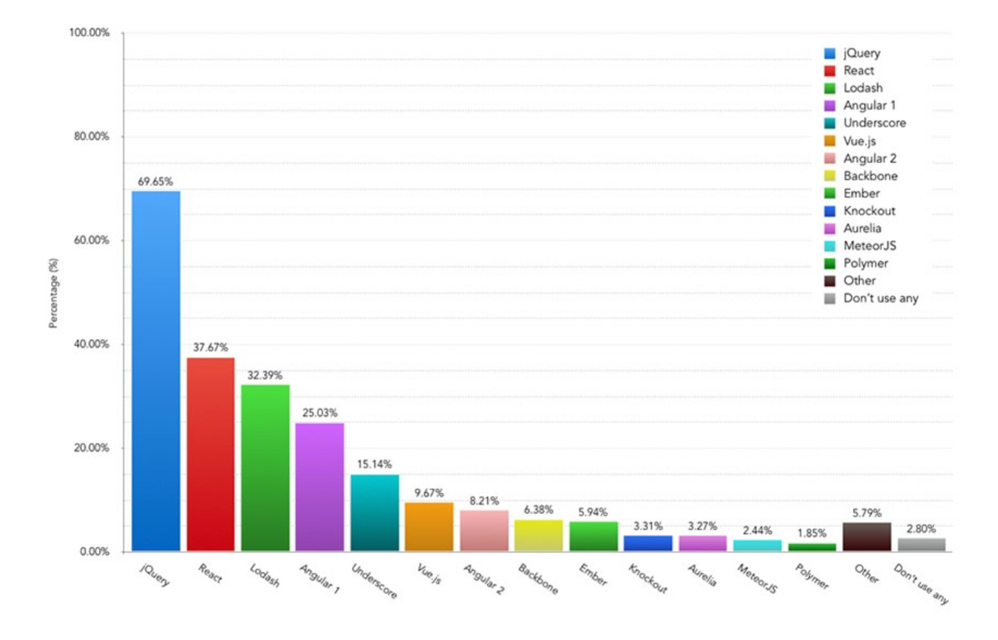

**Difference between a Javascript Framework and a JS library**

We can define a **framework** as a semi completed application, not also provides helper functionalities, it also provides a structure to follow.

While a **library** are packages of code that typically get called by the application to perform a task, like DOM manipulation or HTTP request.

(We use them for a certain task)

**Describe what Bootstrap is and what is it used for. Check out the link**

We use it for creating responsive web design for all platforms.

Is an open source front end developer kit.

Helps you prototype ideas or build an entire app.